B.Khrease Academic Consult, Tagline; distinction with ease
After about a year on this platform (LinkedIn) we are happy to officially present a comprehensive overview of B.Khrease Academic Consult vision, and mission, together with publication of our founding team and sub-team members working behind the screen to bring life to our programs and engagement.
Our Vision: To accelerate the landscape of undergraduate participation in research output in Nigeria and beyond.
Our Mission: We strive to provide the resources and technical know-how to nurture a learned skills-in-demand through networking, mentorship, and collaboration.
Our everyday duties and services @B.Khrease Academic Consult, is providing all our students with a satisfying network links to experts, mentors, and technicians for wet and dry lab procedures assistance in certified laboratories, thesis consultancy, project development and execution. We also engage in collaboration with many other organisations to train students in related skills-in-demand services at ease.

At B.Khrease Academic Consult, BOLD is our core value with acronym that stands for, Believe, Overcome, Lead and Deliver for our student. This is clarified further below.
Believe in your inherent and learned craft.
Overcome any obstacle along the path to success.
Lead the next generation of scientists with shared motives.
Deliver and maintain a legacy for sustainable research practices.

Some of our previous engagement are available on our social platforms.
You can follow us on our official pages
LinkedIn link: @B.KHREASE ACADEMIC CONSULT
https://www.linkedin.com/notifications/?filter=all
Youtube link: @B.KhreaseAcademicConsult
https://www.youtube.com/@B.khreaseAcademicConsult/videos.
Tiktok link: @bkhreaseacademicconsult
https://www.tiktok.com/@bkhreaseacademicconsult?_t=ZS-8zlLUVnPhjO&_r=1
Facebook link: @Health and Habit (BKhrease Academic Consult)
https://www.facebook.com/profile.php?id=100069564954490
Email: Info.bkhrease.ng@gmail.com
WhatsApp: +2348122359970

The journey highlights of B.Khrease Academic Consult
- Founded in 2018 with a clear vision and mission that highlight the significance of expanding undergraduate research capacity in Nigeria and across continents.
- We migrated from academic consulting to undergraduate research mentorship, our impact is measured from classrooms to research communities, and at conferences.
- We are registered under the small and medium enterprises development agency in Nigeria (SMEDAN) in 2022.
- We organised at least one online webinars for undergraduates annually, to position undergraduates with opportunities and information beyond the classroom before graduation.
- We have collaborated with institutes including IBMT, CATDD and many others on research publication to propagate science finding for a sustainable future.
- We have trained more than 1000+ undergraduates since inception, with several of them winning national and international awards from recognised organisations.
- We have written books to support undergraduate thesis writing skills and software to explore for computer biology and bioinformatics analysis.
- Through our founder, we have contributed as co-applicant in recognised national and international grant application drafted to address sustainable development goals (SDG) including 2, 3, 4, 12 and 17.
- In 2025, our business name is now registered under the Cooperate Affairs Commission (CAC) in Nigeria.
- Now, we have grown from just a classroom idea into a movement, powered by people with shared purpose, and guided by shared motive.

Meet the founding core team members
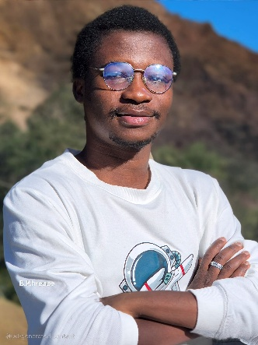
Mr. Christopher B. Olowosoke (B.Khrease), Founder/Team lead; B.Khrease Academic Consult
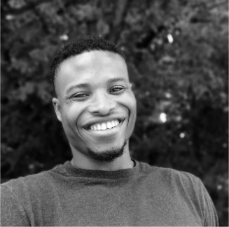
Mr Prosper Obed Chukwuemeka, Research writing coordinator, B.Khrease Academic Consult

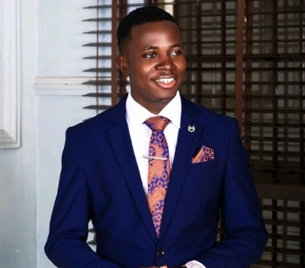
Mr. Tope Abraham Ibisanmi, Program operation coordinator, B.Khrease Academic Consult

Sub-team members
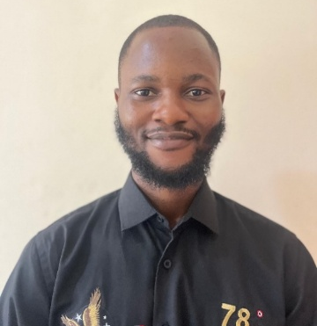
Mr. Victor Omoboyede, Research/laboratory networking manager, B.Khrease Academic Consult


Mr. Richmore Ibeh, Peer mentor lead, B.Khrease Academic Consult
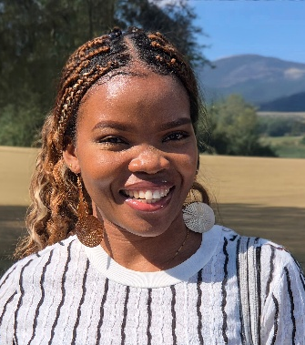
Mrs Nkechi Elizabeth Olowosoke, Resource manager, B.Khrease Academic Consult

Mr. Benson Okorie, Media and communication manager, B.Khrease Academic Consult
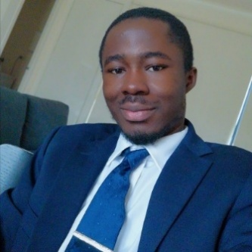
Mr. Jacob Leonard Ago, Partnership and impact manager, B.Khrease Academic Consult

Other team members
Ms Aqsa Munir
Ms Alaba Adebola
Mr. David Oyebamiji
Mr Emmanuel Adebayo
Mr Adegboyega Benjamin
Ms Sarah Olanrewaju Oladejo
Mr. Oreoluwa Ibukunmi Olowosoke

"Education, Management and STEM Career Readiness: Starting from Undergraduate before the Real-world Experience"

